**What is the primary key ?**

* The primary key is a column that uniquely identifies each row in the table.
* A table can have only **one primary key**.
* The primary key must contain **unique values**. Should **not be null** and should **never change**.

**What is Foreign key ?**

* The foreign key is a column or set of columns that is used to **link** two tables.
* The foreign key of one table helps to **connect** with the **primary key of another table**.
* It is used to create links between **two tables**.

**Check the below example for more clarity.**

**Step1: Create table customer**

CREATE TABLE customer(

customerId int primary key not null auto_increment,

custmerName varchar(255),

customerEmail varchar(255),

custmerNumber varchar(255) );

**Step2: To insert data into customer table**

INSERT INTO customer(custmerName,

customerEmail, custmerNumber )

values('yogesh', 'yogi@gmail.com', '787858589'),

('lokesh', 'loki@gmail.com', '787858589'),

('ramesh', 'yoyo@gmail.com', '787858595379'),

('suresh', 'sureshgmail.com', 34638394739);

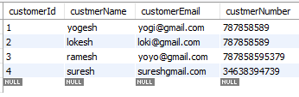

**Step 3: Create table account**

CREATE TABLE account(

customerId int ,

accountId int primary key not null auto_increment,

accounttype varchar(255),

balance int(10),

FOREIGN KEY (customerId) REFERENCES customer(customerId) );

You can also make an auto increment to start value from another value by the following :

ALTER TABLE account auto_increment=100;

**Step 4: To insert data into account table**

INSERT INTO account(customerId, accounttype, balance)

values(1, 'saving', 6500),(2, 'current', 6775),(3, 'saving', 5000),(4, 'current', 893);

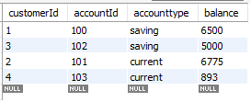

**Step 5:** To retrieve data from two table by using Equi (=) join use below Query:

SELECT customer. customerId, custmerName, accountId, accounttype from customer, account where customer. customerId= account. customerId;

